OVER ALL HIGHEST POSITIONS

Position | Roll No. | Name of Candidate/ Father’s Name & Inst./Home Address/ Contact # | Marks Obtained | Snap
I | 648923 | AMINA KHALIL D/O RAO MUHAMMAD KHALIL  Al-Siraj Public Girls High School, Basti Malook, (Multan).  Basti Malook p/o Same Teh & Distt. Multan  CELL # 0344-3595347 | 1078
II | 637996 | FATIMA YASIN D/O MUHAMMAD YASIN  Grammar Girls Secondary School, D.Block Vehari.  House # 107, Tariq Bin Ziyad Colony, Iftikhar Block, Vehari  CELL # 0332-1640980 | 1077
 | 662198 | MUHAMMAD MAHD RAZA S/O MUHAMMAD AFZAL  Garrison High School Mumtaz Abad, Multan.  House No 1141 Matam Wah O/S Pak Gate Multan  CELL # 0302-7555030
III | 660726 | URWA QASMI D/O HAFIZ AHMAD KHALIL QASMI  Nishat Girls High School, Police Line Road, Multan.  22-Shamsabad Colony Near Eid Gah Multan  CELL # 0300-6363732 | 1076 | 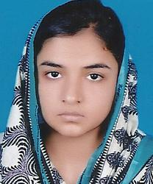

HIGHEST POSITIONS AMONG BOYS SCIENCE GROUP

Position | Roll No. | Name of Candidate/ Father’s Name & Inst./Home Address/Contact # | Marks Obtained | Snap
I | 662198 | MUHAMMAD MAHD RAZA S/O MUHAMMAD AFZAL  Garrison High School Mumtaz Abad, Multan.  House No 1141 Matam Wah O/S Pak Gate Multan  CELL # 0302-7555030 | 1077
II | 653184 | MUHAMMAD USAMA ZAHOOR S/O ZAHOOR AHMAD  Nishat Boys High School Near Lodhi Colony Chowk. Multan.  SIAL HOUSE NEAR FOJI KARYANA STORE AL-ATTA COLONY BOSAN ROAD MULTAN  CELL # 0301-7539827 | 1074 | 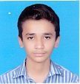
III | 667043 | MUHAMMAD SOHAIL S/O HAJI MUHAMMAD YAQUB  Muslim Public Higher Secondary School, Peoples Colony Mumtazabad, Multan.  HAJI MUHAMMAD YAQUB KARYANA STORE AMEER PUR STATION TEH: KEHROR PACCA DISTRICT LODHRAN  CELL # 0301-7402648 | 1073
 | 611390 | MALIK HUMAYOUN KHALID S/O  MALIK HAJI KHALID MEHMOOD  Govt. Model High School Khanewal.  BLOCK NO. 14 HOUSE NO. 52 MINAR MASJID ROAD KHANEWAL CELL # 0323-6443922
 | 611057 | MUHAMMAD TAUSIF S/O MUHAMMAD ABDULLAH  Govt. Model High School Khanewal.  MIAN HOUSE STREET NO. 01 HASSAN KI CHAKI ZAHOOR ABAD KHANEWAL  CELL # 0300-6882145

HIGHEST POSITIONS AMONG GIRLS SCIENCE GROUP

Position | Roll No. | Name of Candidate/ Father’s Name & Inst./Home Address/Contact # | Marks Obtained | Snap
I | 648923 | AMINA KHALIL D/O RAO MUHAMMAD KHALIL  Al-Siraj Public Girls High School, Basti Malook, (Multan).  Basti Malook p/o Same Teh & Distt. Multan  CELL # 0344-3595347 | 1078
II | 637996 | FATIMA YASIN D/O MUHAMMAD YASIN  Grammar Girls Secondary School, D.Block Vehari.  House # 107, Tariq Bin Ziyad Colony, Iftikhar Block, Vehari  CELL # 0332-1640980 | 1077
III | 660726 | URWA QASMI D/O HAFIZ AHMAD KHALIL QASMI  Nishat Girls High School, Police Line Road, Multan.  22-Shamsabad Colony Near Eid Gah Multan  CELL # 0300-6363732 | 1076

HIGHEST POSITIONS AMONG BOYS GENERAL GROUP

Position | Roll No. | Name of Candidate/ Father’s Name & Inst./Home Address/Contact # | Marks Obtained | Snap
I | 720760 | HAFIZ GHULAM MUHAI-UL-DEEN S/O  GHULAM MUHAMMAD  PRIVATE CANDIDATE DISTRICT MULTAN  C/O HAFIZ MUNEER AHMAD, MADRASSAH  JAME-UL-ULOOM, MASOOM SHAH ROAD MULTAN.  CELL # 0300-7353686 | 1040 | 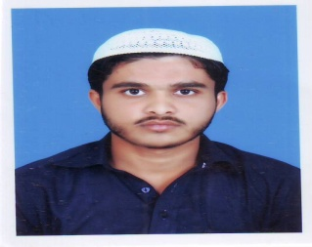
II | 709307 | ABOU BAKAR SIDDIQUE S/O MUHAMMAD ASHRAF  PRIVATE CANDIDATE DISTRICT VEHARI  JAMIYA HANFIYA I BLOCK BUREWALA  CONTACT # 0673353792 | 1019
III | 712042 | WAHEED MURAD S/O MUHAMMAD SHAREEF  Govt. High School, Sargana (Vehari)  MOUZA SARGANA P/O SARGANA TEHSIL MAILSI DISTRICT VEHARI  CELL # 0302-2350182 | 986
 | 720653 | YASIR ISHAQ S/O MUHAMMAD ISHAQ  PRIVATE CANDIDATE DISTRICT MULTAN  C/O HAFIZ MUNEER AHMAD, MADRASSAH  JAME-UL-ULOOM, MASOOM SHAH ROAD MULTAN.  CELL # 0300-7353686 |  | 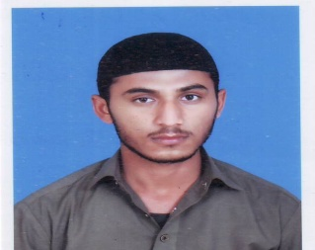

HIGHEST POSITIONS AMONG GIRLS GENERAL GROUP

Position | Roll No. | Name of Candidate/ Father’s Name & Inst./Home Address/Contact # | Marks Obtained | Snap
I | 720083 | SABA GULAM RASOOL D/O SHEIKH GULAM RASOOL  Islamic Ideal Public Girls High School, Masoom Shah Road, Multan.  STREET NO. 9, MUSLIM TOWN, MASOOM SHAH ROAD, MULTAN  CELL # 0333-6104101 | 1031
II | 720185 | AQSA BABAR D/O BABAR BILAL  Islamic Ideal Public Girls High School, Masoom Shah Road, Multan.  STREET NO. 9, MUSLIM TOWN, MASOOM SHAH ROAD, MULTAN  CELL # 0333-6104101 | 1030
III | 711132 | AFSHAN BADAR D/O MUHAMMAD HANIF  Muslim Public Girls Secondary School Dunya pur Road Dokota (Mailsi) Vehari  MUSLIM PUBLIC SECONDARY SCHOOL DOKOTA P/O DOKOTA TEH.MAILSI DISTT. VEHARI  CELL # 0306-7790247 | 1026 | 