OVER ALL HIGHEST POSITIONS

Position | Roll No. | Name of Candidate/ Father’s Name & Inst./Home Address | Marks Obtained | Snap
I | 100192 | AYESHA KHAN KHAKWANI D/O MUHAMMAD SUHAIB KHAN  NISHAT GIRLS HIGH SCHOOL, POLICE LINE ROAD, MULTAN  HOUSE # 1284/47 ST# 13 QADEER ABAD MULTAN,  CELL # 03009633509 | 1070
II | 110059 | MARIA TEHREEM D/O MUHAMMAD SHAHID JAVED  DIVISIONAL PUBLIC SCHOOL (FOR GIRLS), VEHARI  HOUSE NO. 208, L-BLOCK FAISAL TOWN VEHARI, CELL # 0302-7730246 | 1069 | 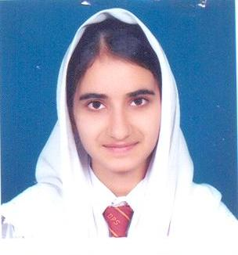
III | 139031 | USAMA ARSHAD S/O ARSHAD ALI  YOUNG SCHOLARS SECONDARY SCHOOL, (BOYS) KHANEWAL  CHAK NO 42/10-R, TEHSIL & DISTRICT KHANEWAL CELL # 03457377742 | 1068
 | 133441 | SOHAIB REHMAN S/O ABDUR REHMAN  THE EDUCATORS GHAZALI CAMPUS HIGH SCHOOL, VEHARI  H # 234-N MAIN ROAD SHARQI COLONY, VEHARI, CELL # 0300-7731285

HIGHEST POSITIONS AMONG BOYS SCIENCE GROUP

Position | Roll No. | Name of Candidate/ Father’s Name & Inst./Home Address | Marks Obtained | Snap
I | 139031 | USAMA ARSHAD S/O ARSHAD ALI  YOUNG SCHOLARS SECONDARY SCHOOL, (BOYS) KHANEWAL  CHAK NO 42/10-R, TEHSIL & DISTRICT KHANEWAL CELL # 03457377742 | 1068
 | 133441 | SOHAIB REHMAN S/O ABDUR REHMAN  THE EDUCATORS GHAZALI CAMPUS HIGH SCHOOL, VEHARI  H # 234-N MAIN ROAD SHARQI COLONY, VEHARI, CELL # 0300-7731285
II | 126082 | AHSAN RASHID RANA S/O RANA RASHID AHMAD  NISHAT BOYS HIGH SCHOOL PIR KHURSHEED COLONY MULTAN  206 BLOCK D SHAH RUKN E ALAM COLONY MULTAN  CELL # 03009636789 | 1067 | 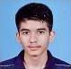
III | 138874 | MUHAMMAD TAIMOOR ABUDLLAH S/O  WASEEM ABDULLAH RANA  THE EDUCATORS BOYS HIGH SCHOOL, KHANEWAL  6-IRSHAD COLONY, TEHSIL & DISTRICT KHANEWAL, CONTACT # 0652557403 | 1060
 | 133438 | ANZAL ISHFAQ S/O ISHFAQ HUSSAIN  THE EDUCATORS GHAZALI CAMPUS HIGH SCHOOL, VEHARI  H # 234-N MAIN ROAD SHARQI COLONY, VEHARI, CELL # 0300-7731285
 | 132239 | MUHAMMAD SAMEEL NAYYAR S/O NAYYAR IRSHAD  DIVISIONAL PUBLIC SCHOOL (FOR BOYS), BUREWALA  CHAK NO 261-EB BUREWALA, DISTRICT VEHARI  CELL # 03336298261,0673351155

HIGHEST POSITIONS AMONG GIRLS SCIENCE GROUP

Position | Roll No. | Name of Candidate/ Father’s Name & Inst./Home Address | Marks Obtained | Snap
I | 100192 | AYESHA KHAN KHAKWANI D/O MUHAMMAD SUHAIB KHAN  NISHAT GIRLS HIGH SCHOOL, POLICE LINE ROAD, MULTAN  HOUSE NO. 208, L-BLOCK FAISAL TOWN VEHARI, CELL # 0302-7730246 | 1070
II | 110059 | MARIA TEHREEM D/O MUHAMMAD SHAHID JAVED  DIVISIONAL PUBLIC SCHOOL (FOR GIRLS), VEHARI  HOUSE NO. 208, L-BLOCK FAISAL TOWN VEHARI, CELL # 0302-7730246 | 1069
III | 110093 | ROBINA ISHAQ KHAN D/O MUHAMMAD ISHAQ  THE EDUCATORS GHAZALI CAMPUS GIRLS HIGH SCHOOL 234 MAIN SHARQI COLONY, VEHARI  H # 234-N, MAIN ROAD SHARQI COLONY VEHARI, CELL # 03007731285 | 1065

HIGHEST POSITIONS AMONG BOYS GENERAL GROUP

Position | Roll No. | Name of Candidate/ Father’s Name & Inst./Home Address | Marks Obtained | Snap
I | 227452 | MUHAMMAD ABDUL RAHMAN MALIK S/O  MUHAMMAD ISMAIL MALIK  PRIVATE:- MADRASSA JAMIA-UL-ULOOM MASOOM SHAH ROAD MULTAN, Cell # 03027353686 | 1037
II | 227451 | HAFIZ NASRULLAH S/O ABDUL HAMEED KHAN  PRIVATE:- MADRASSA JAMIA-UL-ULOOM MASOOM SHAH ROAD MULTAN, Cell # 03027353686 | 1023
III | 227455 | MUHAMMAD YASEEN S/O NIGAH HUSSAIN  PRIVATE:- MADRASSA JAMIA-UL-ULOOM MASOOM SHAH ROAD MULTAN, Cell # 03027353686 | 1000

HIGHEST POSITIONS AMONG GIRLS GENERAL GROUP

Position | Roll No. | Name of Candidate/ Father’s Name & Inst./Home Address | Marks Obtained | Snap
I | 218193 | ANMOL MUNIR D/O MUNIR AHMAD  PRIVATE:- SHAH SHAMAS ROAD MUHALLAH RAZA ABAD MULTAN, CELL # 03124912354 | 1033 | 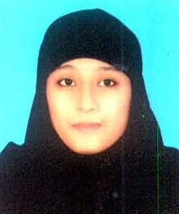
II | 217921 | SHUMAILA D/O MUHAMMAD SAJJAD  PRIVATE:- MY CADET SCHOOL NEAR GONGAY BEHRAY SCHOOL MASOOM SHAH ROAD WRITERS COLONY MULTAN  CELL # 0300-7383463 | 1025 | 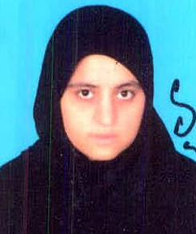
III | 201747 | ANUM HINA D/O MUHAMMAD NISAR  GOVT. ISLAMIA GIRLS HIGH SCHOOL, DAULAT GATE, MULTAN  CELL # 03236265702 | 1024

