OVER ALL HIGHEST POSITIONS

Position | Roll No. | Name of Candidate/ Father’s Name & Inst./Home Address | Marks Obtained | Snap
I | 724067 | MEHRAN SATTAR S/O ABDUL SATTAR  KIPS COLLEGE FOR BOYS 8/1-A GULGASHT COLONY, MULTAN  AAB E HAYAT MILK SHAKE CHOWK FAWARA, JALAL PUR PIR WALA, MULTAN  CELL NO. 03077447817 | 1031 | 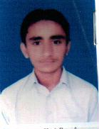
II | 700289 | IQRA KHALID D/O MUHAMMAD KHALID  PUNJAB COLLEGE FOR GIRLS LAHORE MORE, KHANEWAL  BLOCK # 9, STREET # 2, HOUSE # 49, KHANEWAL  CELL NO. 03314947919 | 1029 | 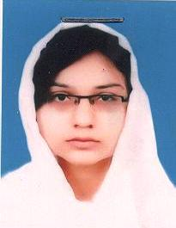
III | 704128 | KAINAT ZULQADAR D/O MUHAMMAD ZULQADAR  CITY COLLEGE OF SCIENCE AND COMMERCE (FOR GIRLS) OFFICERS COLONY, MULTAN  H # 340/41-C WALAYABAD COLONY NO.1 MULTAN  CELL NO. 03345015197 | 1025 | 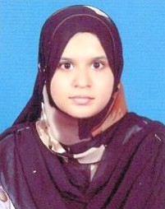

TOP POSITIONS
PRE-MEDICAL GROUP

AMONG BOYS |  |  |  |  |  | AMONG GIRLS
Position | Roll No. | Name of Candidate/ Father’s Name & Inst./Home Address | Marks Obtained | Snap |  | Position | Roll No. | Name of Candidate/ Father’s Name & Inst./Home Address | Marks Obtained | Snap
I | 706205 | SHAJEE UD DIN S/O  WAJEEH TAHIR NAZIR  Punjab College of Information Technology Rasheedabad, Multan  2625/9B Str. # 1 Al-Raheem Colony Nishtar Road Multan  Cell # 03007340594 | 1022 |  |  | I | 700289 | IQRA KHALID D/O  MUHAMMAD KHALID  Punjab College for Girls Lahore More, Khanewal  Block # 9, ST # 2, H # 49, Khanewal  Cell No. 03314947919 | 1029
 | 705469 | AHMAD ALI S/O  ABDUL WADOOD SEHGAL  KIPS College For Boys 8/1-A Gulgasht Colony, Multan  House # 2198/36 St. # 10-B, Muhallah Muhammadi, Near Hazori Bagh Road, Multan. Cell # 03007302102 |  | 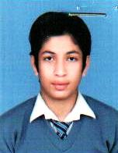 |  | II | 704128 | KAINAT ZULQADAR D/O MUHAMMAD ZULQADAR  City College of Science and Commerce (For Girls) Officers Colony, Multan  H # 340/41-C Walayabad Colony No.1 Multan  Cell No. 03345015197 | 1025
II | 702445 | MUHAMMAD SAAD ANWAR S/O MUHAMMAD ANWAR  Punjab College for Boys Canal Wala Bungla, Burewala  House # 40, V-Block, Burewala  Cell # 03026993125 | 1018 |  |  | III | 704623 | ALISHBAH MAQSOOD D/O  MUHAMMAD MAQSOOD AFZAL KHAN  Punjab College for Women Bosan Road, Multan  Al Afzal 20 New Shalimar Colony Bosan Road Multan  Cell No. 03007305159 | 1024 | 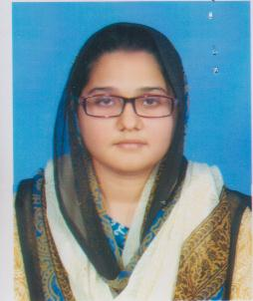
III | 705591 | AFFAN SIDDIQ S/O  MUHAMMAD SIDDIQ  KIPS College For Boys 8/1-A Gulgasht Colony, Multan  House # 29 Str# 12-A Green Huts Zakariya Town, Multan.  Cell # 03007920180 | 1017 |  |  |  | 702330 | MARIUM RAFIQ D/O  RAFIQ AHMED  Punjab College for Girls Canal Wala Bungla, Burewala  House # 42 Satellite Town Burewala  Cell No. 03336298382 |  | 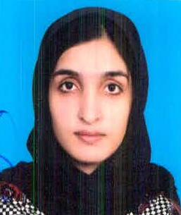
TOP POSITIONS

PRE-ENGINEERING GROUP

AMONG BOYS |  |  |  |  |  | AMONG GIRLS
Position | Roll No. | Name of Candidate/ Father’s Name & Inst./Home Address | Marks Obtained | Snap |  | Position | Roll No. | Name of Candidate/ Father’s Name & Inst./Home Address | Marks Obtained | Snap
I | 724067 | MEHRAN SATTAR S/O  ABDUL SATTAR  KIPS College For Boys 8/1-A Gulgasht Colony, Multan.  Aab E Hayat Milk Shake Chowk Fawara, Jalal Pur Pir Wala, Multan  Cell No. 03077447817 | 1031 |  |  | I | 722524 | FATIMA HAMEED D/O  MUHAMMAD TAHIR HAMEED  Punjab College For Girls Ludden Road,Vehari.  House # 395 Sharqi Colony Vehari  Cell No. 03007736643 | 1001 | 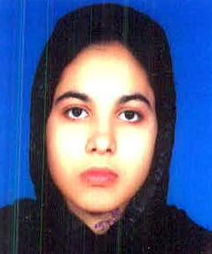
II | 725238 | BAQIR ALI S/O SALEEM RAZA  Punjab College of Information Technology Rasheedabad, Multan  H.# 947/20 ST. NO.2 Ismail Zai Colony Near Eid Gah Multan.  Cell No. 03336145621 | 1022 |  |  | II | 723808 | RAFIA NAEEM D/O  MUHAMMAD NAEEM  Punjab College for Women Bosan Road, Multan.  House # 2563 20-E Hafiz Jamal Kachi Abadi outside Doulat Gate Multan. Cell No. 0300634885 | 998 | 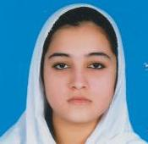
III | 724604 | SAIM MUHAMMAD ADIL  S/O MUHAMMAD ASLAM  Punjab College of Information Technology Rasheedabad, Multan  H/NO,103 Block -B Shah Rukn-eAlam Colony Multan  Cell No. 03007183780 | 1012 |  |  | III | 723498 | TAHIRA IQBAL D/O  DR. MUHAMMAD PERVAIZ IQBAL  Punjab College for Women Bosan Road, Multan.  Assistant Warden House Tariq Hall Nishter Medical College Multan  Cell No. 03007389530 | 984 | 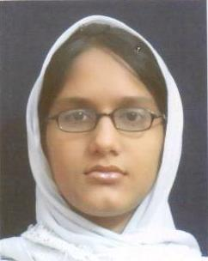
 | 724958 | MUHAMMAD AHMAD ZAFAR  S/O CH. ZAFAR IQBAL ZAFAR  City College of Science and Commerce (For Boys) Officers Colony, Multan  H # 2 ST # 7 V-Block New Multan  Cell No. 03006325131 | 1012
TOP POSITIONS

HUMANITIES GROUP

AMONG BOYS |  |  |  |  |  | AMONG GIRLS
Position | Roll No. | Name of Candidate/ Father’s Name & Inst./Home Address | Marks Obtained | Snap |  | Position | Roll No. | Name of Candidate/ Father’s Name & Inst./Home Address | Marks Obtained | Snap
I | 774425 | TARIQ AZIZ S/O  ABDUL AZIZ NAFEES  Private: KHANEWAL  Chak No 67/15-l Mianchanu P.O 67/15-L MPS  Cell No. 03030430474 | 901 |  |  | I | 785414 | LUBNA SHAHZADI D/O  SIJJAD HUSSAIN  City College of Science and Commerce (For Girls) Officers Colony, Multan  H # 1416/18-A Hazori Bagh Road Quaid-E-Azam Street Multan  Cell No. 03320665050 | 982 | 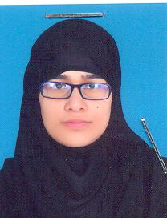
II | 786044 | MUHAMMAD AYUB KHAN S/O  MUHAMMAD NAWAZ KHAN  Private: MULTAN  H.No.1919/10 Mahallah Kiri Jamandan Khoni Burj Multan  Cell No. 0312808179 | 891 |  |  | II | 784918 | ZAHRA SARDAR D/O  HAFIZ SARDAR MUHAMMAD  Private: MULTAN  158 Defence Officers Colony Sher Shah Road Multan  Cell No. 03008637378 | 953 | 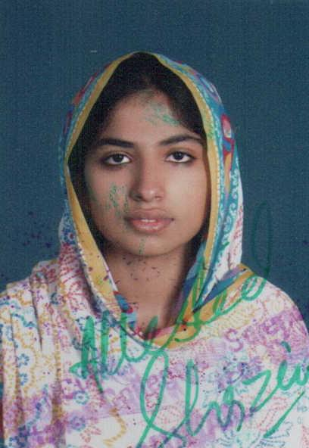
III | 785720 | YOUAIL YOUSAF S/O  YOUSAF MASIH  Govt. Emerson College, Multan  H# A-1 Nawshband Colony Khanewal, Multan  Cell No. 03004339179 | 886 |  |  | III | 785110 | MEHAK AFZAL D/O  MUHAMMAD AFZAL  Private: MULTAN  Makki Street No 3 House No. 3 New North Gulgasht Colony Multan  Cell No. 03007328087 | 945 | 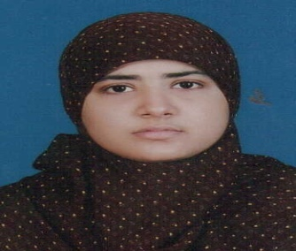

TOP POSITIONS
GENERAL SCIENCE GROUP

AMONG BOYS |  |  |  |  |  | AMONG GIRLS
Position | Roll No. | Name of Candidate/ Father’s Name & Inst./Home Address | Marks Obtained | Snap |  | Position | Roll No. | Name of Candidate/ Father’s Name & Inst./Home Address | Marks Obtained | Snap
I | 740144 | MUHAMMAD RIZWAN SHARIF  S/O MUHAMMAD SHARIF  Comprehensive Science inter College, Jahanian  Tehsil Head Quater Hospital Jahanian  Cell No. 03006881676 | 981 |  |  | I | 741859 | LUBNA SHAHZADI D/O  MUHAMMAD SHARIF  Punjab College for Girls Canal Wala Bungla, Burewala  Sundas Block Sadiq Town Burewala  Cell No. 03136992990 | 949 | 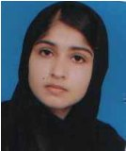
II | 744085 | NOUMAN MASOOD S/O  MASOOD RASHID  Superior College for Boys Neel Kot Bosan Road,Multan | 941 |  |  | II | 741663 | HADIA AHMAD D/O  MUKHTAR AHMAD  Superior College For Girls, Burewala  House # 18, P block burewala,Vehari  Cell No. 03437301984 | 948 | 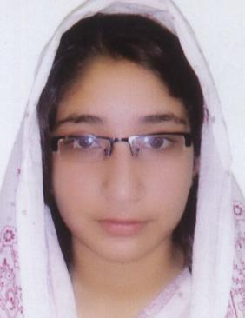
III | 742052 | MUHAMMAD USMAN S/O  MUHAMMAD ASHRAF  Punjab College for Boys Canal Wala Bungla, Burewala  Bashir Town Chungi No. 5 Burewala  Cell No. 03367132559 | 917 |  |  | III | 743286 | NAGEENA BANO D/O  ALLAH DEWAYA  Punjab College for Women Bosan Road, Multan  Muhallah Chah Ghulam Muhammad Wala Near New Central Jail Multan  Cell No. 03069100957 | 947 | 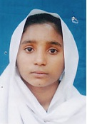
TOP POSITIONS
COMMERCE GROUP

AMONG BOYS |  |  |  |  |  | AMONG GIRLS
Position | Roll No. | Name of Candidate/ Father’s Name & Inst./Home Address | Marks Obtained | Snap |  | Position | Roll No. | Name of Candidate/ Father’s Name & Inst./Home Address | Marks Obtained | Snap
I | 760542 | MUHAMMAD REHMAN  S/O MUHAMMAD RAMZAN  Leaders College of Commerce and Science, Mianchannu  House No. 260 Street Basti Chamrung Mian Channu  Cell No. 03009697719 | 976 |  |  | I | 761242 | SANA AHMAD D/O  MUHAMMAD AHMAD  Punjab College for Girls Canal Wala Bungla, Burewala.  Adda Pakhi More Chak No. 1/WB, Teh. & Distt. Vehari  Cell No. 03336268601 | 983 | 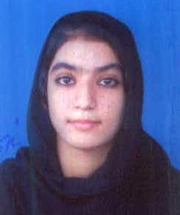
II | 762388 | ALI NAZEER  S/O NAZEER AHMAD  Superior College for Boys Neel Kot Bosan Road, Multan.  Basti Nau Nawab Pur Road Multan. | 973 |  |  | II | 761726 | NUDRAT IQBAL D/O  IQBAL AHMAD QURESHI  Punjab College for Women Bosan Road, Multan  188-A Azmat Wasti Road Multan  Cell No. 03009631914 | 975 | 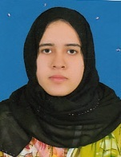
III | 761330 | MUHAMMAD ABDULLAH  S/O PERVAIZ AKHTAR  Punjab College for Boys Canal Wala Bungla, Burewala  House # 5, Street # 1, Shah Faisal Colony, Burewala  Cell No. 03006998198 | 967 | 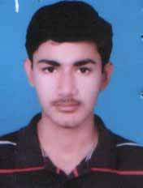 |  | III | 761807 | ANEESA NAZAR D/O  NAZAR ABBAS  Punjab College for Women Bosan Road, Multan  Sargana Street Piran Ghaib Road Manzoor Colony Multan  Cell No. 03007349609 | 972 | 