BOARD OF INTERMEDIATE & SECONDARY EDUCATION, MULTAN.
RESULT GAZETTE FOR THE INTERMEDIATE (ANNUAL) EXAMINATION, 2012.

OVER ALL HIGHEST POSITIONS

Position | Roll No. | Name of Candidate/ Father’s Name & Inst./Home Address | Marks Obtained
I | 506336 | Meher Fatima D/O Dr. Irshad Ahmad Ansari  Nishat College of Science For Girls, Multan | 1031 | 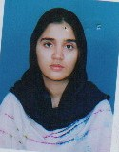
II | 504822 | Muhammad Suhaib Qasim S/O Hafiz Muhammad Qasim  Punjab College of Information Technology, Multan | 1029 | 
II | 506013 | Zaira Shahid D/O Shahid Niaz Shahid  Nishat College of Science For Girls, Multan | 1029 | 
II | 517320 | Nayab Zahra D/O Shujaat Ali  Punjab College for Women, Multan | 1029 | 
III | 515953 | Areeb Tariq S/O Tariq Mahmood Qureshi  Rise College of Science, Multan | 1028 | 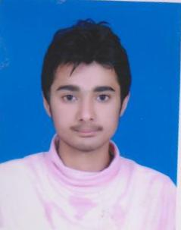

BOARD OF INTERMEDIATE & SECONDARY EDUCATION, MULTAN.
RESULT GAZETTE FOR THE INTERMEDIATE (ANNUAL) EXAMINATION, 2012.
HIGHEST POSITIONS
AMONG BOYS |  |  |  |  |  | AMONG GIRLS
Position | Roll No. | Name of Candidate/ Father’s Name & Inst./Home Address | Marks Obtained |  |  | Position | Roll No. | Name of Candidate/ Father’s Name & Inst./Home Address | Marks Obtained
I | 504822 | Muhammad Suhaib Qasim S/O  Hafiz Muhammad Qasim  Punjab College of Information Technology, Multan | 1029 |  |  | I | 506336 | Meher Fatima D/O  Dr. Irshad Ahmad Ansari  Nishat College of Science For Girls, Multan | 1031
II | 515953 | Areeb Tariq S/O  Tariq Mahmood Qureshi,  Rise College of Science, Multan | 1028 |  |  | II | 506013 | Zaira Shahid D/O  Shahid Niaz Shahid  Nishat College of Science For Girls, Multan | 1029
 |  |  |  |  |  | II | 517320 | Nayab Zahra D/O Shujaat Ali,  Punjab College for Women, Multan | 1029
III | 504596 | Muhammad Humayoun Rashid S/O Chaudhary Abdul Rashid  Punjab College of Information Technology, Multan | 1027 |  |  | III | 505720 | Rida Fatima D/O  Muhammad Arshad  Nishat College of Science for Girls, Multan | 1027 | 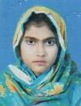
 |  |  |  |  |  | III | 502327 | Azka Zafar D/O  Muhammad Ali Zafar  Divisional Public Higher Secondary School, Sahiwal | 1027 | 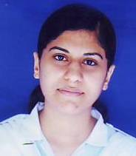
 |  |  |  |  |  | III | 502346 | Ramsha Zafar D/O  Zafar Iqbal Fayyaz  Punjab College for Girls Sahiwal | 1027 | 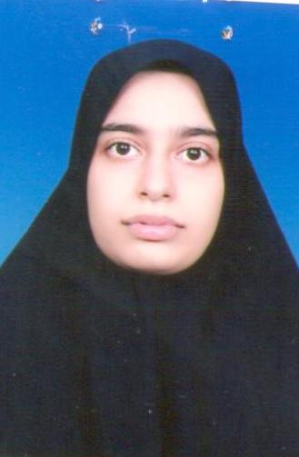
 |  |  |  |  |  | III | 505856 | Beenish Javaid D/O  Javaid Iqbal  Nishat College of Science, Multan | 1027 | 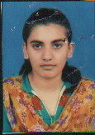
BOARD OF INTERMEDIATE & SECONDARY EDUCATION, MULTAN.
RESULT GAZETTE FOR THE INTERMEDIATE (ANNUAL) EXAMINATION, 2012.
TOP POSITIONS
PRE-MEDICAL GROUP

AMONG BOYS |  |  |  |  |  | AMONG GIRLS
Position | Roll No. | Name of Candidate/ Father’s Name & Inst./Home Address | Marks Obtained |  |  | Position | Roll No. | Name of Candidate/ Father’s Name & Inst./Home Address | Marks Obtained
I | 504822 | Muhammad Suhaib Qasim S/O  Hafiz Muhammad Qasim  Punjab College of Information Technology, Multan | 1029 |  |  | I | 506336 | Meher Fatima D/O  Dr. Irshad Ahmad Ansari  Nishat College of Science For Girls, Multan | 1031
II | 504596 | Muhammad Humayoun Rashid S/O Chaudhary Abdul Rashid  Punjab College of Information Technology, Multan | 1027 |  |  | II | 506013 | Zaira Shahid D/O  Shahid Niaz Shahid  Nishat College of Science For Girls, Multan | 1029
III | 504928 | Ghulam Yaseen S/O  Muhammad Amin  Punjab College of Information Technology, Multan | 1022 |  |  | III | 505720 | Rida Fatima D/O Muhammad Arshad  Nishat College of Science for Girls, Multan | 1027
 |  |  |  |  |  | III | 502327 | Azka Zafar D/O  Muhammad Ali Zafar  Divisional Public Higher Secondary School, Sahiwal | 1027
 |  |  |  |  |  | III | 502346 | Ramsha Zafar D/O Zafar Iqbal Fayyaz  Punjab College for Girls Sahiwal | 1027
 |  |  |  |  |  | III | 505856 | Beenish Javaid D/O Javaid Iqbal  Nishat College of Science, Multan | 1027

BOARD OF INTERMEDIATE & SECONDARY EDUCATION, MULTAN.

RESULT GAZETTE FOR THE INTERMEDIATE (ANNUAL) EXAMINATION, 2012.

TOP POSITIONS

PRE-ENGINEERING GROUP

AMONG BOYS |  |  |  |  |  | AMONG GIRLS
Position | Roll No. | Name of Candidate/ Father’s Name & Inst./Home Address | Marks Obtained |  |  | Position | Roll No. | Name of Candidate/ Father’s Name & Inst./Home Address | Marks Obtained
I | 515953 | Areeb Tariq S/O  Tariq Mahmood Qureshi,  Rise College of Science, Multan | 1028 |  |  | I | 517320 | Nayab Zahra D/O Shujaat Ali,  Punjab College for Women, Multan | 1029
II | 515744 | Usama Naseer S/O  Muhammad Naseer  Superior College of Science, Multan | 1022 |  |  | II | 517349 | Momina Ishaq D/O  Rana Muhammad Ishaq  Punjab College for Women, Multan | 1006 | 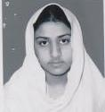
III | 516960 | Zeeshan Tahir S/O  Muhammad Tahir  Punjab College of Information Technology, Multan | 1018 |  |  | III | 517377 | Mahnoor Ali D/O  Rao Ali Noor Shafique  Punjab College for Women, Multan | 1004 | 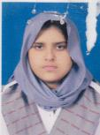

BOARD OF INTERMEDIATE & SECONDARY EDUCATION, MULTAN.
RESULT GAZETTE FOR THE INTERMEDIATE (ANNUAL) EXAMINATION, 2012.

TOP POSITIONS
GENERAL SCIENCE GROUP

AMONG BOYS |  |  |  |  |  | AMONG GIRLS
Position | Roll No. | Name of Candidate/ Father’s Name & Inst./Home Address | Marks Obtained |  |  | Position | Roll No. | Name of Candidate/ Father’s Name & Inst./Home Address | Marks Obtained
I | 523710 | Sheikh Muhammad Tauha Faheem S/O Sheikh Muhammad Faheem  Govt. Emerson College, Multan | 929 |  |  | I | 524372 | Anum Hassan D/O Hassan Raza  Punjab College for Women, Multan | 1002 | 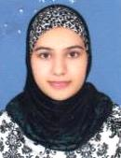
II | 520773 | Moin Akhtar S/O Pervaiz Akhtar  Excellence Boys Higher Secondary School, Lodhran | 922 |  |  | II | 524385 | Sana Alvi D/O  Muhammad Asif Alvi  Superior College of Science, Multan | 993 | 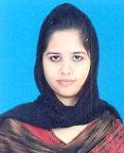
III | 522949 | Muhammad Azhar Husnain S/O Mehmoob Hussain Siddiqi  Govt. Post Graduate College, Vehari | 906 |  |  | III | 522039 | Aliza Mustafa D/O  Ghulam Mustafa  Saffa Educational Complex College for Girls Sahiwal | 979 | 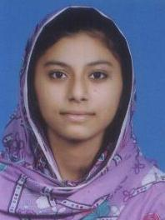
III | 524165 | Muhammad Asif Nawaz S/O Muhammad Nawaz  Punjab College of Information Technology, Multan | 906 | 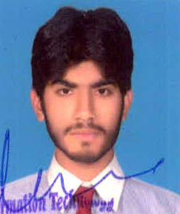

BOARD OF INTERMEDIATE & SECONDARY EDUCATION, MULTAN.

RESULT GAZETTE FOR THE INTERMEDIATE (ANNUAL) EXAMINATION, 2012.

TOP POSITIONS

COMMERCE GROUP

AMONG BOYS |  |  |  |  |  | AMONG GIRLS
Position | Roll No. | Name of Candidate/ Father’s Name & Inst./Home Address | Marks Obtained |  |  | Position | Roll No. | Name of Candidate/ Father’s Name & Inst./Home Address | Marks Obtained
I | 530550 | Muhammad Waris S/O  Ahmad Yar  Leaders College of Commerce and Science, Mianchannu Khanewal | 959 |  |  | I | 534761 | Fatima Ahmad D/O  Tanveer Ahmad  Punjab College for Women, Multan | 979 | 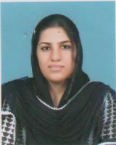
II | 534370 | Zafeer Shahid S/O  Muhammad Shahid Hussain  Punjab College of Commerce, Multan | 947 |  |  | II | 534807 | Mahnoor Khawaja D/O Shahid Mehmood  Punjab College for Women, Multan | 975 | 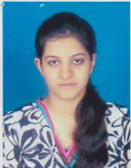
III | 530615 | Ehtsham Khalid S/O  Muhammad Khalid  Leaders College of Commerce & Science Mianchannu, Khanewal | 938 |  |  | III | 534737 | Arshia Shareef D/O  Shareef Ahmad  Multan College of The Educators, Multan | 965 | 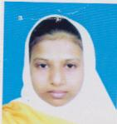

BOARD OF INTERMEDIATE & SECONDARY EDUCATION, MULTAN.

RESULT GAZETTE FOR THE INTERMEDIATE (ANNUAL) EXAMINATION, 2012.

TOP POSITIONS

HUMANITIES GROUP

AMONG BOYS |  |  |  |  |  | AMONG GIRLS
Position | Roll No. | Name of Candidate/ Father’s Name & Inst./Home Address | Marks Obtained |  |  | Position | Roll No. | Name of Candidate/ Father’s Name & Inst./Home Address | Marks Obtained
I | 562699 | Aisar-Ul-Qasmi S/O  Muhammad Hussain  Govt. Post Graduate College, Vehari | 920 |  |  | I | 541087 | Noshin Mumtaz D/O  Mumtaz Ahmad  Jinnah Girls Higher Secondary School, Khanewal | 961 | 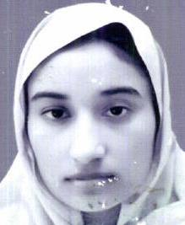
II | 571872 | Muhammad Shafiq S/O  Muhammad Hussain  Govt. Higher Secondary School, Raja Ram Shujabad, Multan | 894 | 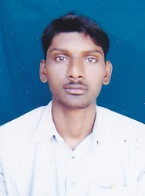 |  | II | 570205 | Ameena Fatima D/O  Tariq Mehmood  Mailsi School of Educators Maisli, Vehari | 955 | 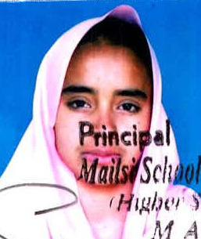
III | 553102 | Muhammad Kamal Tanveer S/O Muhammad Adil  House No. 98, M-Block Arifwala, Pakpattan | 887 | 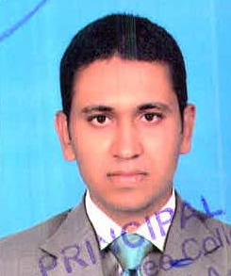 |  | III | 564845 | Hafiza Asma Sakhawat D/O Rana Sakhawat Ali  Govt. Post Graduate College for Women, Vehari | 951 | 

